# **Investigating with Splunk**

**Q1** **How many events were collected and Ingested in the index main?**

Use the query index=main

*12256*

**Q2 On one of the infected hosts, the adversary was successful in creating a backdoor user. What is the new username?**

Use the google to find the EventID of the user account creating which is 4720 and query that

index=main EventID="4720"

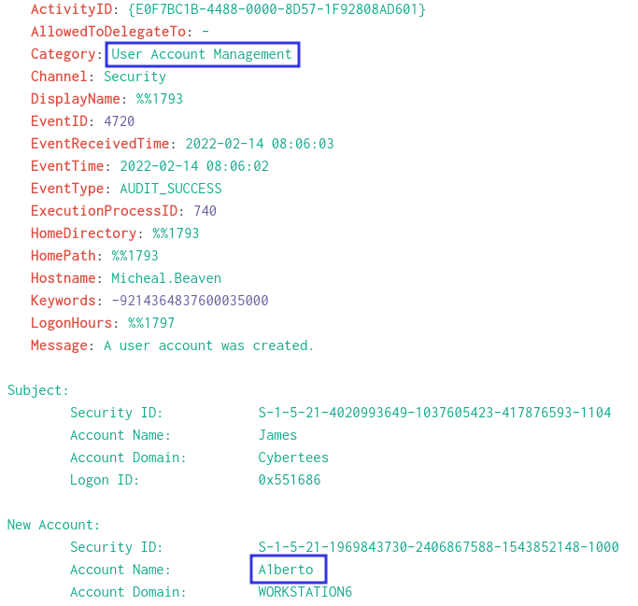

*A1berto*

Q3 **On the same host, a registry key was also updated regarding the new backdoor user. What is the full path of that registry key?**

I used the event id to find the log along with the hostname and the query is

index=main Micheal.Beaven EventID=13

*HKLM\SAM\SAM\Domains\Account\Users\Names\A1berto*

**Q4 Examine the logs and identify the user that the adversary was trying to impersonate.**

The user name that we figured out is *A1berto*  is similar to the name Alberto which is present in the user list in the left panel so the attacker is typing to mimic as the legitimate user

*Alberto*

**Q5 What is the command used to add a backdoor user from a remote computer?**

For this i used the EventId 4688 and the query is *index=main EventID=4688 "net user"*

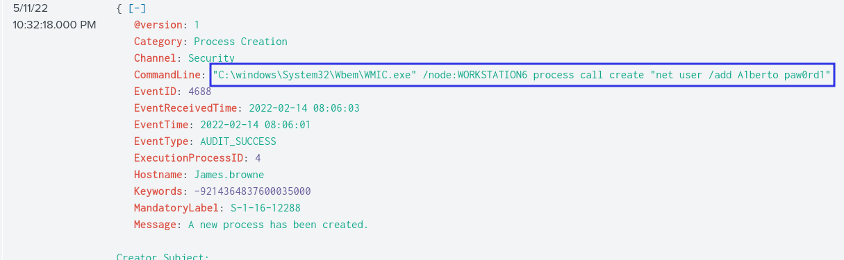

*C:\windows\System32\Wbem\WMIC.exe" /node:WORKSTATION6 process call create "net user /add A1berto paw0rd1*

**Q6 How many times was the login attempt from the backdoor user observed during the investigation?**

I used the Eventid for the both failed and successful login attempts from that user but no traces were there the EventId for Success 4624 and Failed is 4635

*index=main A1berto EventID=4625*

*index=main A1berto EventID=4624*

So the answer is zero (0)

**Q7 What is the name of the infected host on which suspicious Powershell commands were executed?**

We need to use the query used in the 5th question in order to find the hostname

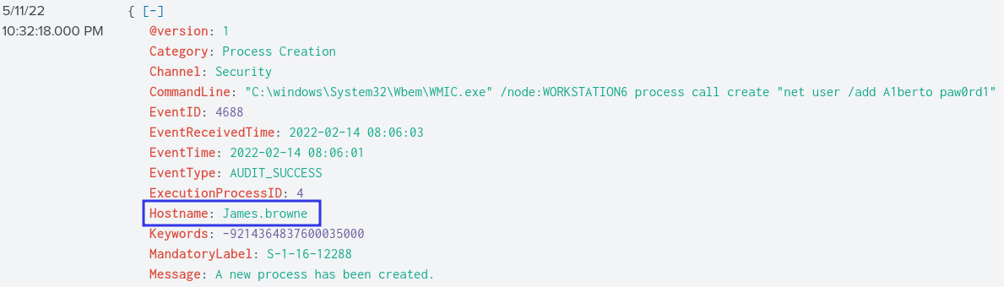

*James.browne*

**Q8 PowerShell logging is enabled on this device. How many events were logged for the malicious PowerShell execution?**

4103 or 4104 are the EventID for the powershell / cmd login

Use them to filter out

*index=main EventID="4103"*

*79*

***Q9* An encoded Powershell script from the infected host initiated a web request. What is the full URL?**

Use the logs of the previous question and get the encoded url and paste cyber chef , grab the url then defang it

First take take the complete encoded text 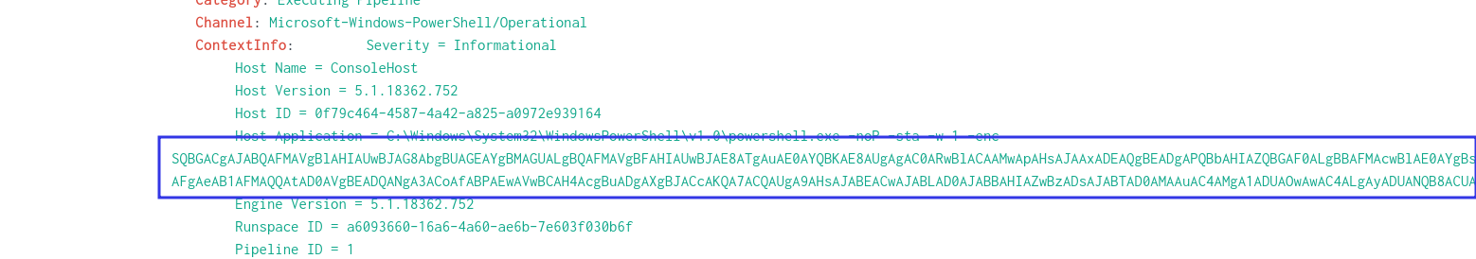

Then use cyber chef to decode this

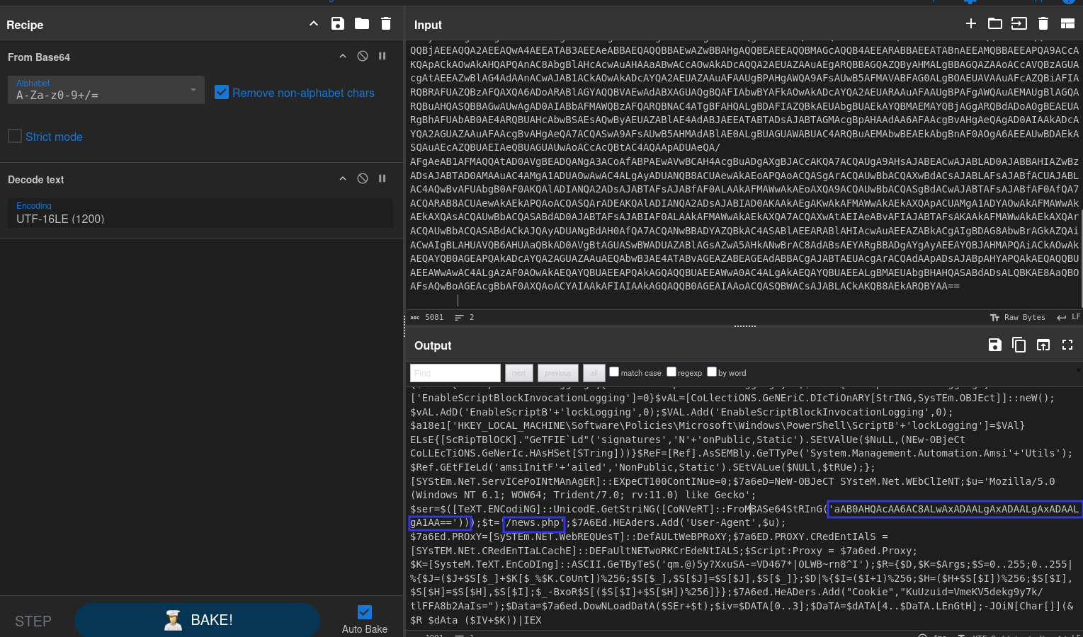

Now take the base64 string again along to code this

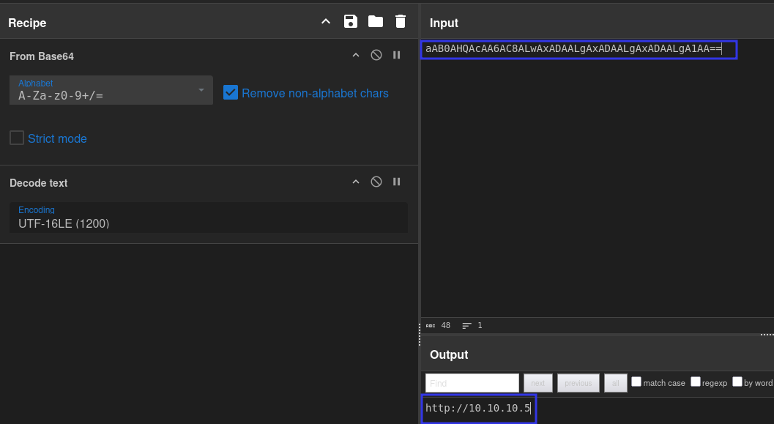and now add the /news.php to the url and use the defang url recipe

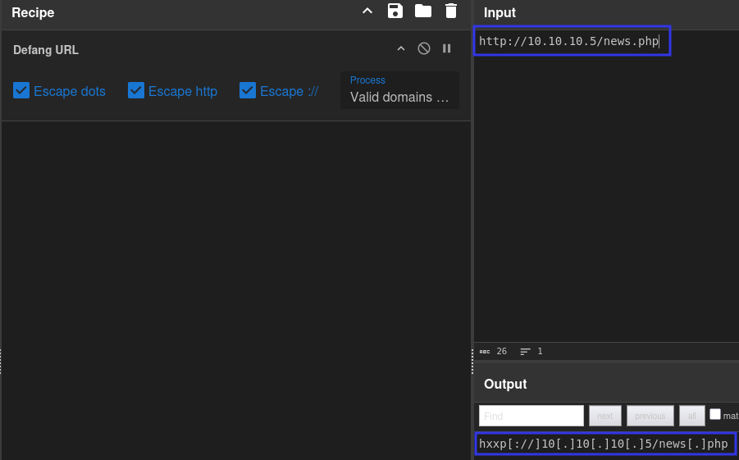

*hxxp[://]10[.]10[.]10[.]5/news[.]php*